# 

Project Report Template

1 INTRODUCTION

1.1 Overview

Radisson Hotel is an international chain headquarted in the united states. Radisson means an individual property operated under a license agreement with radission hotel international. It is an international and dynamic the hotel group.

1.2 purpose

At Radisson hotel group they strive to be the first choice in the mind of guest, owners and talent. At the hard of Radisson hotel group is our brand promise every moments matters.

2. PROBLEM DEFINITION & DESIGN THINKING

2.1 empathy map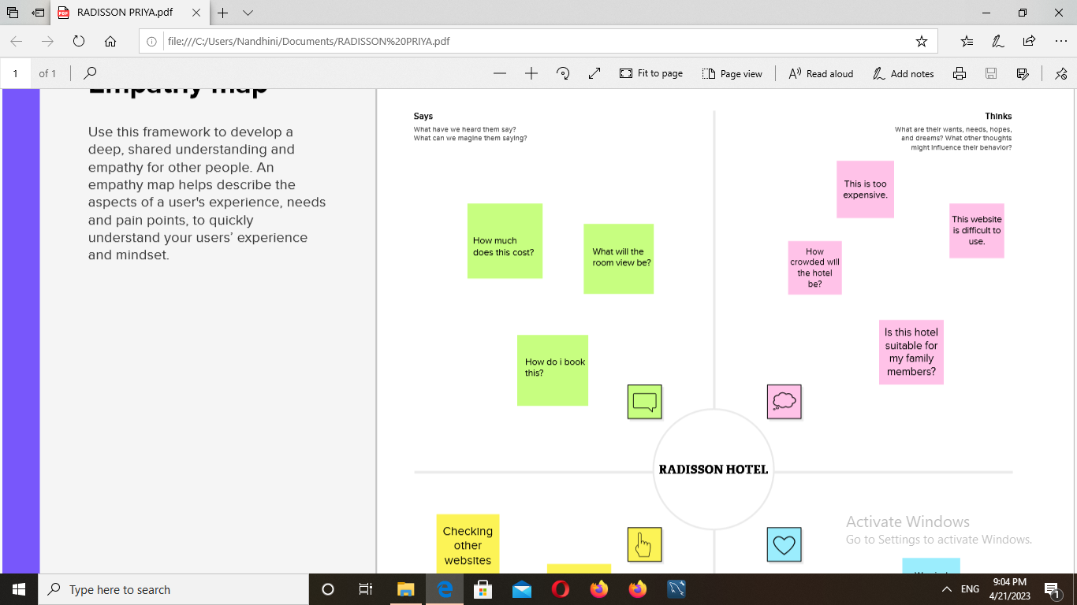

2.2 ideation & brainstorming map

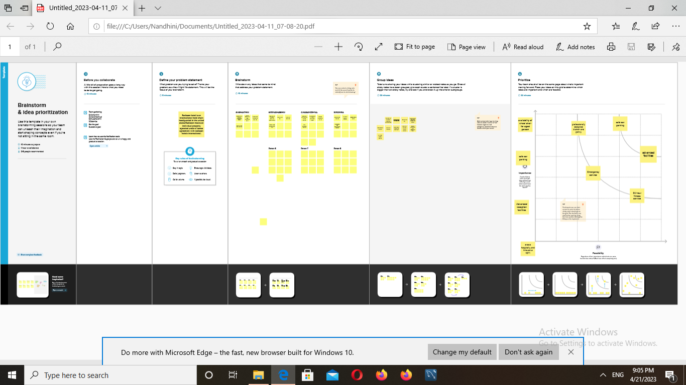

3 RESULT

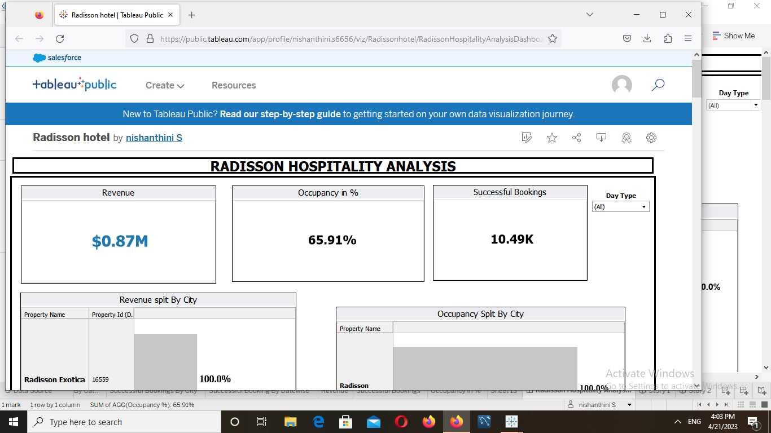

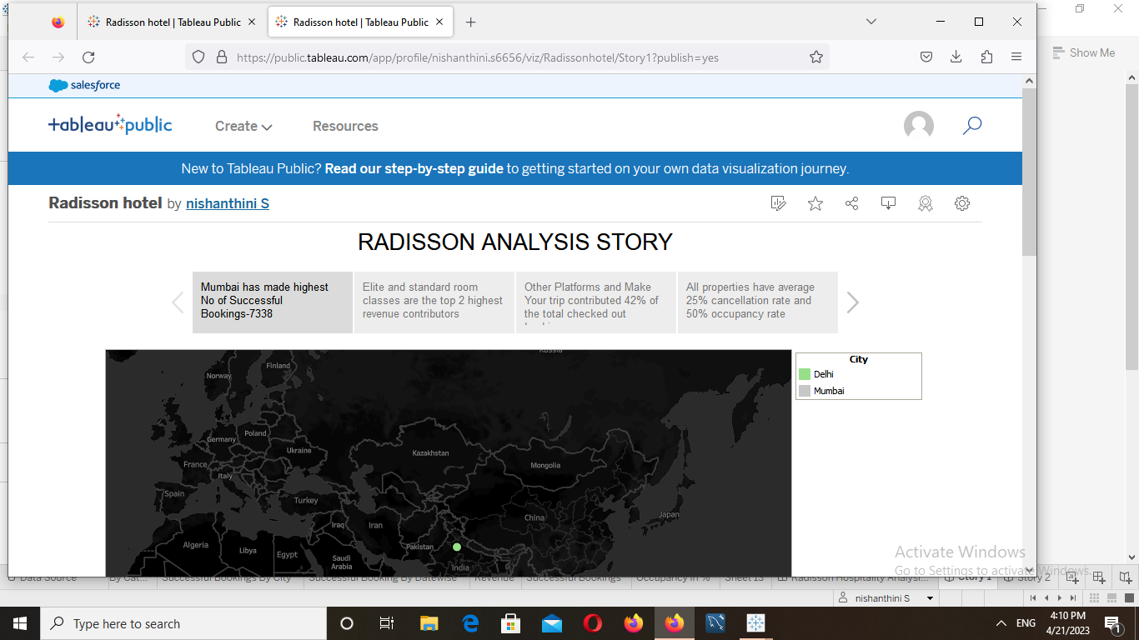

4 ADVANTAGES & DISADVANTAGES

Advantages

There are so many advantages in our topic

* Service
* Wide network
* Mentorship program
* Free upgrades
* Exclusive discounts

Disadvantages

Some of disadvantages in it they are

* Expansion plans
* High promotions costs
* Too much spread

5 APPLICATIONS

There are some of the applications in it

* Reduced room rates
* Location flexibility
* Creater networking opportunities
* Reduced travel prices
* More customer interactions
* Economic development

6 CONCLUSION

The most luxurious and stylish hotel in our country.increased our cities beauty .By attracting the tourist from outside country.Helping our countries economy to develop faster and promise that a developing country like that the potential of being a develop country someday

7 FUTURE SCOPE

Radisson hotel group one of the world leading hotel groups has received confirmation and validation of its near team science based targets aligned with its commitment to be net zero by the future years .it get more advanced in future.